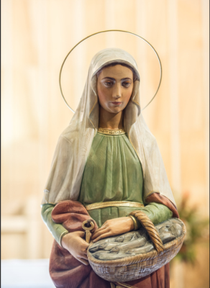

This keepsake has been designed so that you may carry **Hope**with you at all times.

Blessed by   
Father Jacek Cichy

St Martha’s Strathfield

Hope

You may wish to:

Put it in your pocket.

Carry it in your wallet or handbag.

Thread a ribbon and wear it.

Hang it in your car on the   
rear view mirror.

Attach it to your key ring.

Or, you may simply want to hold it in the palm of your hand.

We invite you to share a photo of how you are carrying Hope by uploading it to the   
St Martha’s Facebook page:

https://fb.me/stmarthasparishstrathfield

St Martha’s Parish Strathfield wishes to sincerely thank

Frank Argiro and his team at

for custom designing & creating this keepsake to help us inspire Hope in our community.

**0415 242 017**

Trophies - Awards - Engraving - Gifts   
& Custom Framing



This keepsake has been designed so that you may carry **Hope**with you at all times.

Blessed by   
Father Jacek Cichy

St Martha’s Strathfield

Hope

You may wish to:

Put it in your pocket.

Carry it in your wallet or handbag.

Thread a ribbon and wear it.

Hang it in your car on the   
rear view mirror.

Attach it to your key ring.

Or, you may simply want to hold it in the palm of your hand.

We invite you to share a photo of how you are carrying Hope by uploading it to the   
St Martha’s Facebook page:

https://fb.me/stmarthasparishstrathfield

St Martha’s Parish Strathfield wishes to sincerely thank

Frank Argiro and his team at

for custom designing & creating this keepsake to help us inspire Hope in our community.

**0415 242 017**

Trophies - Awards - Engraving - Gifts   
& Custom Framing

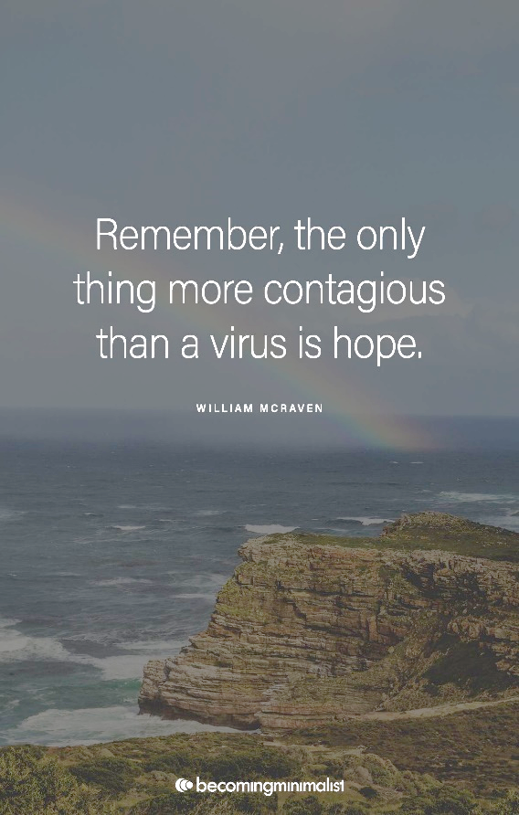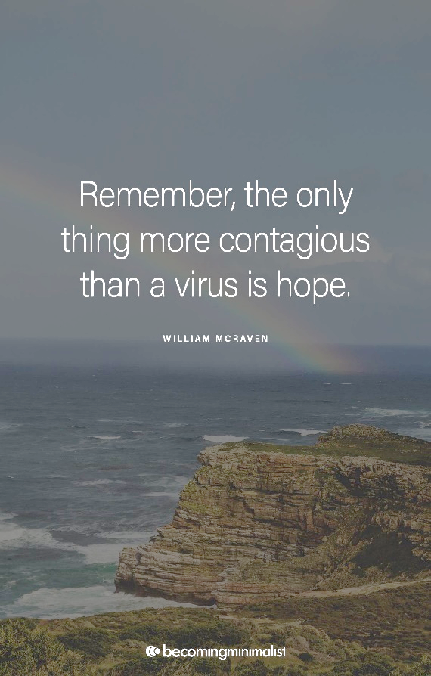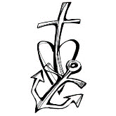[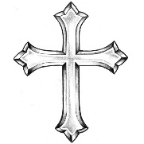](http://clipart-library.com/crosses.html)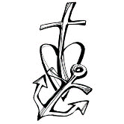[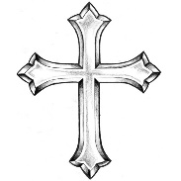](http://clipart-library.com/crosses.html)

“We may not always have a comfortable life and we will not always be able to solve all of the world's problems at once but don't ever underestimate the importance you can have because history has shown us that courage can be contagious and hope can take on   
a life of its own.”

Michelle Obama

“We may not always have a comfortable life and we will not always be able to solve all of the world's problems at once but don't ever underestimate the importance you can have because history has shown us that courage can be contagious and hope can take on   
a life of its own.”

Michelle Obama

**Prayer**

Heavenly father,   
I am your humble servant,

I come before you today in need of hope.

There are times when I feel helpless,

There are times when I feel weak.

I pray for hope.

I need hope for a better future.

I need hope for a better life.

I need hope for love and kindness.

Some say that the sky is at it's

darkest just before the light.

I pray that this is true,   
for all seems dark.

I need your light, Lord, in every way.

I pray to be filled with your light from

head to toe.

To bask in your glory.

To know that all will be right again in the world,

as you have planned,

and as you want it to be.

Help me to walk in your light,   
and live my life in faith and glory.

In your name I pray,   
Amen.

I need your light, Lord, in every way.

I pray to be filled with your light from

head to toe.

To bask in your glory.

To know that all will be right again in the world,

as you have planned,

and as you want it to be.

Help me to walk in your light,   
and live my life in faith and glory.

In your name I pray,   
Amen.

**Prayer**

Heavenly father,   
I am your humble servant,

I come before you today in need of hope.

There are times when I feel helpless,

There are times when I feel weak.

I pray for hope.

I need hope for a better future.

I need hope for a better life.

I need hope for love and kindness.

Some say that the sky is at it's

darkest just before the light.

I pray that this is true,   
for all seems dark.